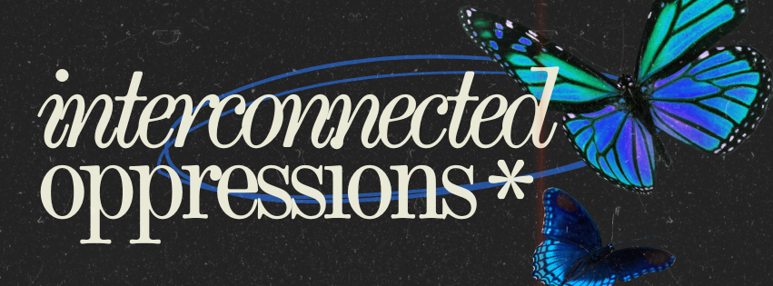
Creative Methodologies Workshops 2025

Overview
These workshops focus on creative methodologies as alternative ways of being, thinking, and doing within the academy. Our aim is to foster a collaborative space where doctoral students and creative practitioners can come together to experiment, innovate, and reimagine the ways in which research is conducted and expressed.
By inviting a diverse group of poets, graphic novelists, creative writers, artists, and filmmakers to lead semi-structured workshops, we seek to challenge traditional academic paradigms. Together, we aim to explore new methods of expression and representation, unlocking fresh perspectives for engaging with complex, multi-layered, and intersectional topics.

Theme for 2025: Interconnected Oppressions: Exploring Intersectional Experiences through Creative Expressions.
The 2025 workshop will center on the theme of Interconnected Oppressions: Exploring Intersectional Experiences through Creative Expressions. Through this theme we hope to understand how creative methods can help researchers grapple with intersectional oppressions and create spaces for transformation and healing. Participants will engage with creative approaches to examine how multiple forms of oppression intersect and manifest in lived experiences. Through this, we aim to uncover new ways of understanding, navigating, and representing these intricate dynamics.
Creative methodologies will serve as a lens for navigating these difficult topics, offering tools to rethink and reshape how we approach intersectional struggles. Together, we hope to envision transformative paths for addressing oppressions and fostering more inclusive and equitable academic practices.

Objectives
- To cultivate a transdisciplinary and transnational community of doctoral students and creative practitioners.
- To explore and practice creative methodologies for researching and representing complex and intersectional experiences.
- To experiment with innovative forms of expression that challenge conventional academic approaches.
- To provide participants with tools and inspiration to integrate creative methodologies into their own research and practice.

Format
- A series of semi-structured workshops led by creative practitioners, including poets, graphic novelists, writers, artists, and filmmakers.
- Hands-on sessions designed to experiment with creative methods of inquiry and representation.
- Collaborative spaces for reflection, dialogue, and feedback among participants.
This workshop invites participants to imagine and enact alternative ways of doing research—transforming how we navigate, understand, and communicate the complexities of intersectional experiences. Consider this as your official invitation to inspiration!

Registration
If you would be interested in participating in these workshops, please register via the following form: https://forms.office.com/e/reQPh0Lywj

